Setup minikube at your local and explore creating namespaces (Go through official documentation).

Commands used :

Minikube start

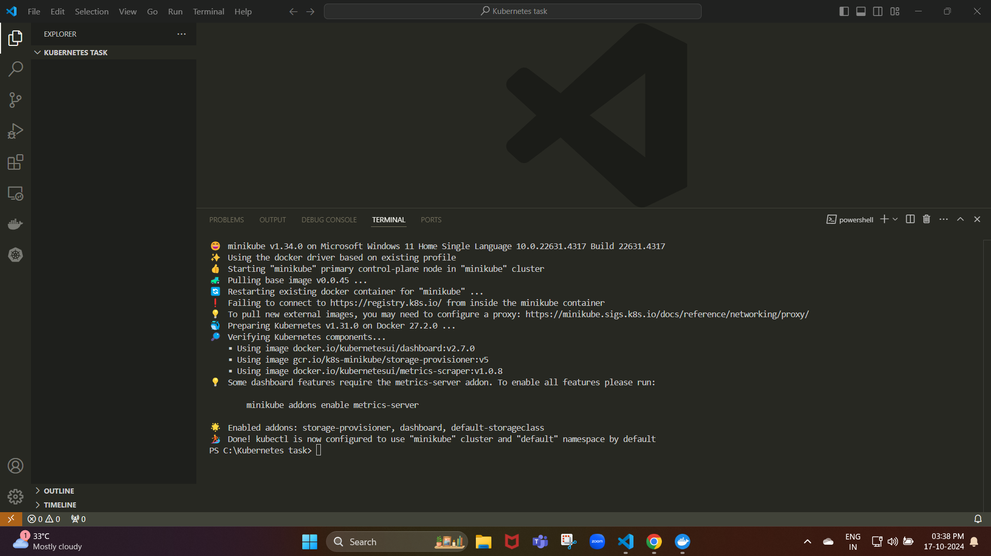

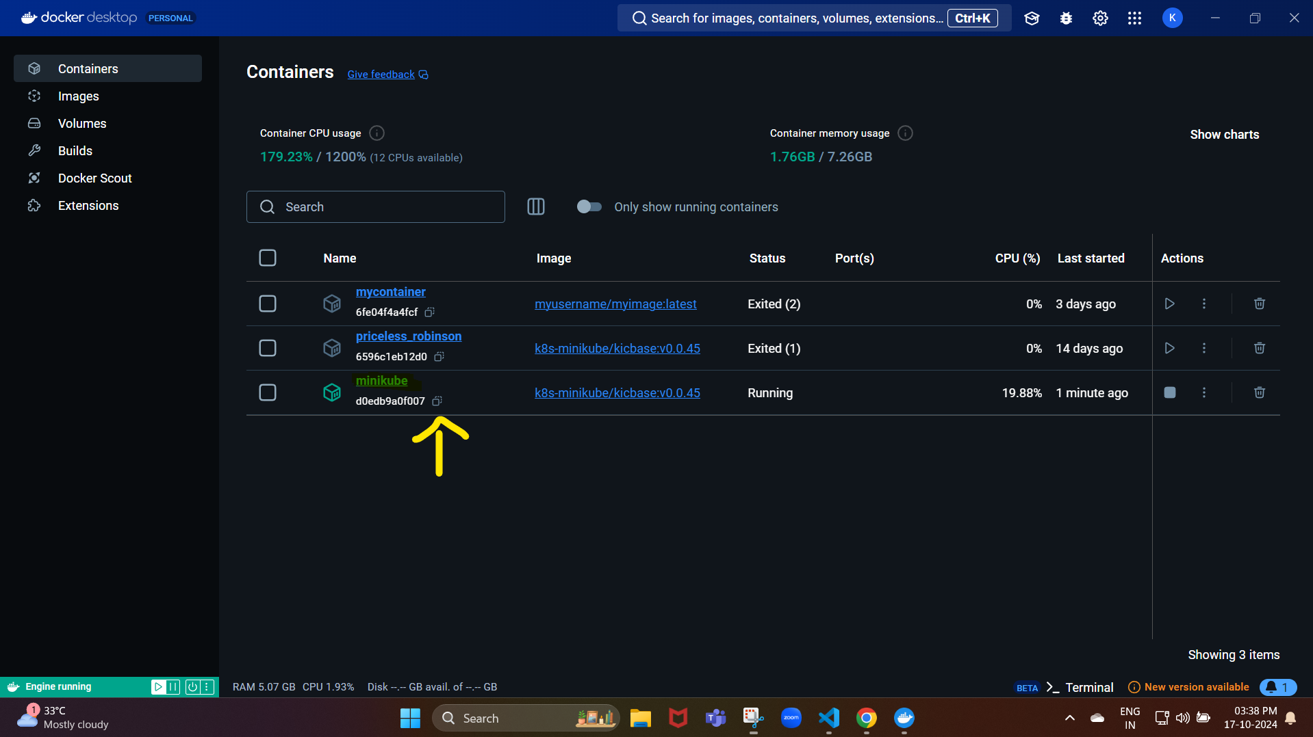

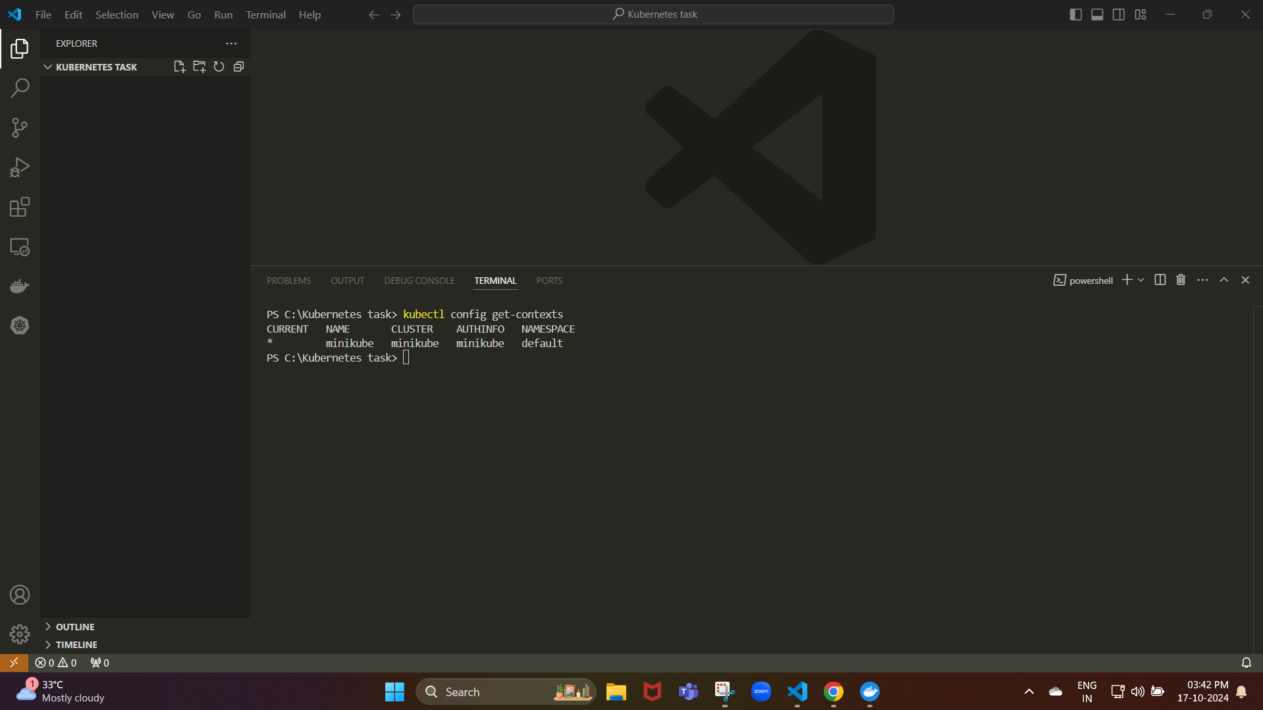

kubectl config get-contexts

It should list Minikube as one of the available contexts.

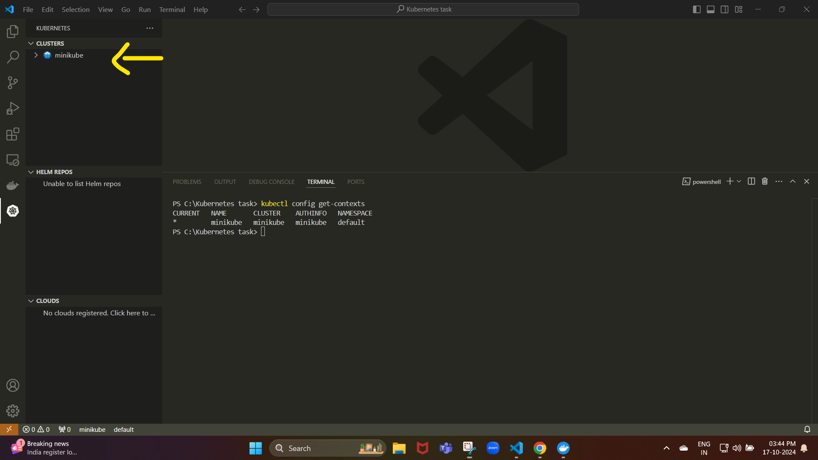

Here we can see our cluster is running.

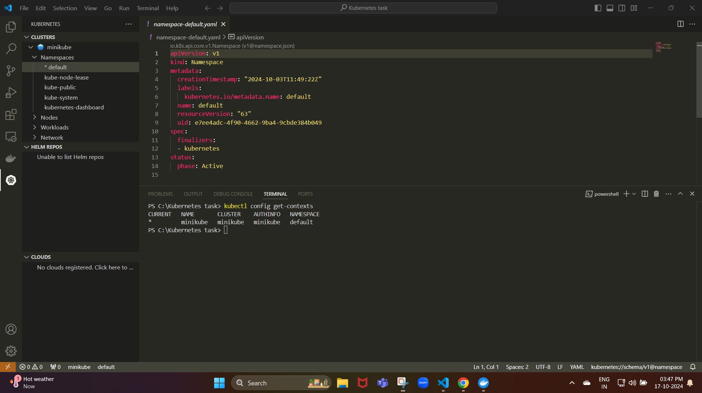

Here, we can see the namespace as default.yaml

Namespace:

A namespace in Kubernetes is like a folder or container that helps organize and isolate resources (like pods, services, and deployments) within a Kubernetes cluster.

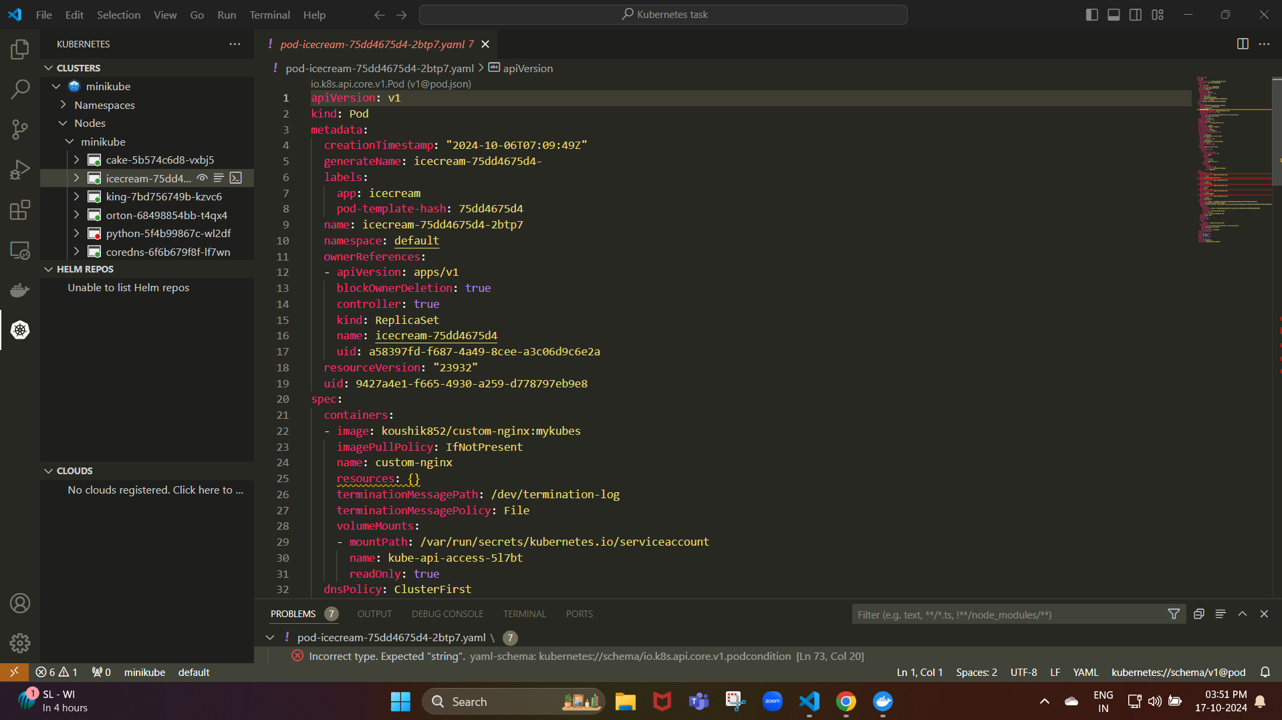

Here, we can see that the pod has been created.